ROSS CARRERA Hybrid Mixte Bike - $135

Reply to: sale-382281072@craigslist.org
Date: 2007-07-26, 9:08AM EDT
ROSS CARRERA Hybrid Mixte Ladies Bike
This is a nice bike, runs well and looks good, has sseveral near new parts.
10 speed
RED/WHITE
ON TUBE SAYS: cR-mO
Aluminum Rims, Brakes, and Shifters
Shimano RS Deraileurs
Casual Bike handle Bars
double Ladies Mixte Top Bar
New Sprockets in rear, new Chain, ahrdly any use to them.
Tires as pictured may be taken off, I will put on NEW Tires 27x1-1/4" after a few days
$135 or best soonest offer.
Was Overhauled 5 years ago, and has been ridden very little since(Green grease still squeezing out of hubs!!), nevertheless sold As Is, but I can make any adjustments or fixes you need within reasonable time of purchase.
Call 323 490 3006
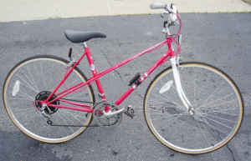 | 